Download Hex files to PC and download to connected MicroBit or type code as seen in the images below.
Transmitter Block Code
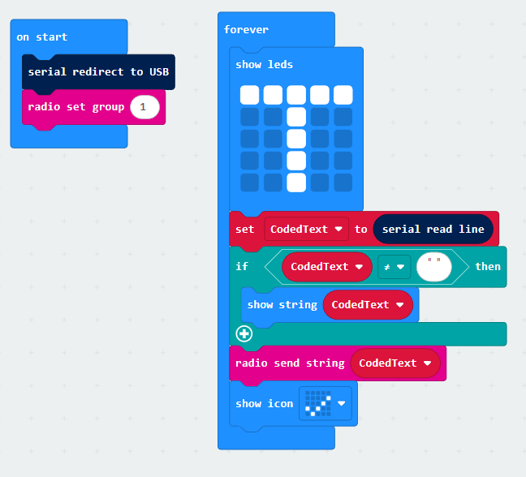

Receiver Block Code
